Request Details

Engagement # (YYYY/MM/DD + initials eg: 20110801rst): 20190606RH
TITLE: CST Cerner project manager (BURNABY CENTRE FOR MENTAL HEALTH & ADDICTIONS – bcmha) SOW ISSUE Date: June 26, 2019
REsponse due Date: July 11 @12:00PM
Consulting Category or categories | Seniority level (**SEE BELOW)
Project Management and Implementation | Senior

This Consulting Statement of Work may only be used to engage Service Providers on the Pre-Qualified Consultant List and only for Consulting Categories appearing on the Pre-Qualified Consultant List. Service Providers and Independent Contractors (aka Consultants) who are not on the Pre-Qualified Consultant List may not be considered for an engagement using this SOW.

Conditions applying to response:
- No responses will be accepted after 12:00pm on the Closing Date specified above.
- Statement of Work must be signed by an authorized signatory of the sole proprietor, firm, corporation or other entity submitting a proposal for purposes of this engagement (the “Service Provider”).
- All Consultants proposed MUST meet the requirements for the Seniority Level stated above.
- Complete a Statement of Work for EACH Consultant in respect of the engagement hereunder. The maximum number of individuals each Service Provider may put forward as a Consultant for this engagement is 1. Include a resume for each Consultant proposed and each individual Consultant forming part of a team proposed for this engagement. Each resume is to be a separate attachment.
- Submit a one page cover letter with this Statement of Work.
- Reference the engagement number and title, as indicated above, in the subject line of the reply email.
E.g. “20110801RST Change Management for Project X” and send along a cover letter with the Statement of Work to:
Name: Christina Tolkamp Email: Christina.Tolkamp@phsa.ca
- Do not contact any employee of the Purchaser other than the individual named above regarding the status of submitted responses.
- Submit any questions about the engagement or the process by email to the individual named above.
- All capitalized terms shall have the same meaning as defined in the Statement of Work except as otherwise expressly defined in the Contract Terms and Conditions for General Health Care Consulting Services and IMIT Consulting Services (the “Terms and Conditions”).
Failure to comply with any of the above requirements may result in rejection of your proposal at the sole discretion of the Purchaser
Following the Closing Date:
- Responses will be evaluated in the following areas:

Evaluation Criteria Weights
Approach | 10%
Qualification and Education | 50%
Price | 40%
Total | 100%

- Interviews may be held with Consultants that have been short-listed in step 1.
- References of Consultants may be contacted by the Purchaser and the results of the reference checks used to determine the successful Consultant.

**Please note: You may receive this Statement of Work more than once if you are pre-qualified in multiple categories.

Seniority Level Descriptions

- Intermediate
  - A Degree in Consulting Category related disciplines and a minimum of two (2) years of related Consulting Category experience; or
  - A Diploma in Consulting Category related disciplines and a minimum of three (3) years of related Consulting Category experience; or
  - A Certificate in Consulting Category related disciplines and a minimum of four (4) years of related Consulting Category experience; or
  - An absolute minimum of six (6) years of directly related Consulting Category experience.
- Senior
  - A Degree in Consulting Category related disciplines and a minimum of four (4) years of related Consulting Category experience; or
  - A Diploma in Consulting Category related disciplines and a minimum of five (5) years of related Consulting Category experience; or
  - A Certificate in Consulting Category related disciplines and a minimum of six (6) years of related Consulting Category experience; or
  - An absolute minimum of eight (8) years of directly related Consulting Category experience.
- Expert
  - A Degree in Consulting Category related disciplines and a minimum of six (6) years of related Consulting Category experience; or
  - A Diploma in Consulting Category related disciplines and a minimum of seven (7) years of related Consulting Category experience; or
  - A Certificate in Consulting Category related disciplines and a minimum of eight (8) years of related Consulting Category experience; or
  - An absolute minimum of ten (10) years of directly related Consulting Category experience.
- Specialist
  - Multiple Degrees (or other qualifications) relevant to Consulting Category disciplines and a minimum of ten (10) years of related Consulting Category experience; or
  - An absolute minimum of fifteen (15) years directly related Consulting Category experience.

Engagement Definition
(completed by Purchaser’s representative)
- Purchaser:

PHSA of 1795 Willingdon Avenue, British Columbia, V5C 6E3, is the contracting authority on behalf of:

(double click the checkbox you want to use and choose “checked”)

Fraser Health Authority (“FHA”)
Interior Health Authority (“IHA”)
Northern Health Authority (“NHA”)
Provincial Health Services Authority (“PHSA”)
Vancouver Coastal Health Authority (“VCH”) or VCH acting as agent for Providence Health Care Society (PHC)
Vancouver Island Health Authority (“VIHA”)
(the “Purchaser”)

- Department:

Burnaby Centre for Mental Health & Addictions (BCMHA), BC Mental Health and Substance Use Services

- Project Description:

Background:
The Clinical & Systems Transformation (CST) is a multi-year project designed to improve the safety, quality and consistency of patient care across three British Columbia health organizations: Vancouver Coastal Health (VCH), the Provincial Health Services Authority (PHSA) and Providence Health Care (PHC).

This transformation will be supported by the implementation of a common clinical information system (Cerner) that will replace multiple aging existing systems.

Benefits for patients will include enhanced medication safety; an integrated approach with increased consistency of care; faster access to results and medication therapies; and less time repeating themselves during consultations or undergoing duplicate tests.

Overall project scope:
The Burnaby Centre for Mental Health will implement CST in December 2019. This role will provide Project Management support for the BCMHA CST implementation. This involves coordinating with CST to ensure deliverables are met across all implementation work streams. The project is managed by a governance committee to support timely decision making and escalation of issues/risks.

Objectives
- Successful implementation of CST Cerner at BCMHA. Long term there are several clinical KPIs that will provide measurable results.

Timeline
July 2019 to March 2020

- Reporting to:

Reporting to Implementation Director, BCMHSUS, matrix reporting to Rebecca Hahn, Executive Director, Corporate & Clinical Support Services, BCMHSUS

- Services Required:

One consultant with Project Management experience and experience leading EHR implementations.

Scope of work
- In partnership with CST, establishes a detailed project charter, plans and objectives to outline timelines and project deliverables. Reporting to Implementation Director, executes project plan using proven project methodologies, ensures successful and coordinated completion of project components, facilitates consensus with stakeholders as needed and ensures readiness for project implementation.
- Tracks project progress according to project plan and identified metrics. Monitors and reports on the status of projects and major barriers encountered. Makes recommendations regarding projects scope and related changes required to facilitate a successful outcome. Implements or contributes to the implementation of effective processes to assess project risks, identify risk mitigation strategies and monitor risk throughout the project lifecycle.
- Develops and monitors project budgets; uses best practice methods to thoroughly monitor and adhere to allocated budgets. Responsibilities include reporting variance, planning and adjusting to meet projections and annual targets, approving expenditures and preparing summaries and is accountable for its own operating budget.

The following diagram shows the work streams for the CST Implementation Project. The Project Manager is responsible for supporting all aspects of the work within each work stream.

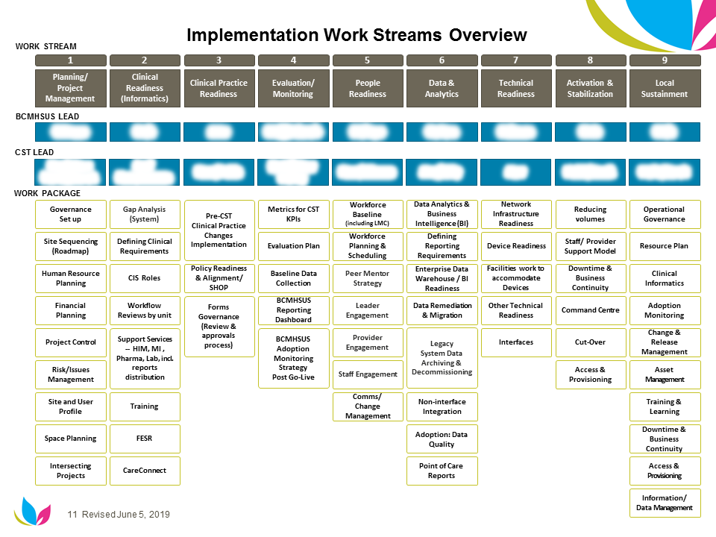

Key activities and deliverables | Date
In partnership with CST, support the development of implementation project plan in alignment with the overarching CST project plan. | July 2019
Oversee execution of selected work streams. Identify dependencies and work in collaboration with teams to ensure timelines are met e.g. design, testing, education, communications etc. | July – March 2020
Update risk register and issues log and ensure mitigations are in place for each risk/issue | July 2019
Support decision making by the governance committees and ensure timely escalations to get resolutions | July – March 2019
Develop/collaborate with work stream leads to coordinate work and receive regular progress updates on key milestones and deliverables | July – Jan 2019
Support the creation of status monitoring to track progress/status report using identified reporting structures | July – Jan 2019
Assist with the identification and summarize critical success factors; develop a readiness document with go/no go criteria in collaboration with CST | Oct 2019
Support activation including establishing a command centre, triaging issues and ensuring the system is well adopted. | Dec 2019
Prepare for handoff to operations teams. Develop supporting documentation. | Feb – March 2020

- Pricing Options Preferred:

Service provider to provide an hourly rate

- Constraints and Special Considerations:

- Must be able to start immediately.
- Must be able to travel between three primary sites – 4949 Heather St., 590 W 8th Ave, 3405 Willingdon Avenue, Burnaby
- Will need to work over holiday period in December
- Specific Qualifications or Experience Required:

- Project management experience (PMP preferred). Intermediate user of MS Office and MS Visio and MS Project
- Experience working on EHR implementations
- Experience working in a mental health environment preferred
- Strong leadership skills and ability to form partnerships.
- Demonstrated ability to problem solve, work collaboratively and deliver results.
- Proven ability to foster a collaborative team approach to decision-making.
- Effective financial management skills.
- Exceptional communication and inter-personal skills.
- Ability to negotiate and find resolutions to complex issues. Ability to interact tactfully and effectively with staff at all organizational levels, both internally and externally.
- Excellent organization and time management skills.

- Start Date of This Engagement: ASAP

- End Date of This Engagement: March 27th, 2020

- Possible Future Extensions to This Engagement:

Number of Potential Extensions: Two (2)
Duration of Each Potential Extension: Six (6) months

Please indicate the number and duration of any extensions that may be required. For example, Number of Potential Extensions: Two (2)
Duration of Each Potential Extension: Six (6) months

If no extensions are listed or if all of the extensions are used, then a new procurement process will be required. If Process A was run, then Potential Extensions may not be entered if the Estimated Total Value of the engagement will exceed $50K.

- Terms and Conditions:

Contract Terms and Conditions for General Health Care Consulting Services and IMIT Consulting Services previously accepted in the pre-qualification application process are non-negotiable and will apply in respect of the engagement envisaged in terms hereof.

The Indemnity, Liability and Insurance clause applicable for this engagement is:

(please check one)

General Health Care Consulting Services (Article 11 of the Terms and Conditions applies)
IMIT Consulting Services (Article 12 of the Terms and Conditions applies)

- Incumbent

None

Engagement Service Provider Response
(completed by the Service Provider)
1. Service Provider information:

(The “Service Provider”)
Service Provider to provide their legal name and address.
2. Service Provider Primary Contact:

Service Provider to provide their primary contact name, email address and phone number.
3. Service Provider registered sales tax number (GST/PST/HST):

Service Provider to provide sales tax number.
4. Consultant Proposed:

Service Provider to provide name(s) of Consultant(s) proposed for this engagement
5. Relationship:

Service Provider to disclose relationship of proposed Consultant(s) to the Service Provider:

Principal
Employee
Subcontractor (refer to definitions in Contract Terms and Conditions)

NOTE: By completing this section the Service Provider acknowledges that the Consultant(s) it is proposing is not a current employee of the Customer.
6. Summary response:

Service Provider to summarize their understanding of Purchaser’s requirements.
7. Proposed Approach:

Service Provider to provide details on how they intend to meet the Purchaser’s requirements.
8. Qualifications and Education of proposed Consultant:

Service Provider to provide details of the Consultant proposed for the assignment including related experience and skills
9. Expected Effort:

Service Provider to estimate the number of effort hours or days by Consultant. (NOTE** number of effort hour or days and duration of work effort is NOT predicated by the start and end date of the engagement.

10. Availability of Proposed Consultant:

Service Provider to indicate the ability of the proposed Consultant to commence work on the Start Date stated in Section 9 of the Engagement Definition.
- 11. Proposed Pricing:

Service Provider to provide detailed pricing for this assignment which aligns to the pricing option preferred by the Purchaser as described in Section 6 of the Engagement Definition. Estimated out of pocket expenses must be listed separately. Payment of such expenses must be pre-approved by the Purchaser in accordance with existing travel expense policy.
- 12. Value Added:

Service Provider to identify value added services offered for this specific assignment including tools to be applied, access to specialized no fee expertise etc.
- Insurance Coverage:

- The Service Provider selected by the Purchaser for the engagement set out herein will provide the Purchaser with a Certificate of Insurance from the Service Provider’s insurance company / broker indicating the types and amounts of insurance coverage held by the Service Provider as evidence that the Service Provider meets the Insurance requirements set forth in Section 12 of the Engagement Definition above and in compliance with the Contract Terms and Conditions for General Health Care Consulting and IMIT Consulting agreed to as a condition of being accepted on the Consulting Pre-Qualification List. The Certificate of Insurance is required before a Purchase Order will be issued by Supply Chain. For clarity, this requirement applies to the Service Provider whether it is a consulting firm or a sole proprietor (e.g. independent contractor).

14. Service Provider Conflict of Interest Declaration

The Service Provider and its shareholders, directors, officers, agents, servants or employees will take all reasonable steps to ensure avoidance of all direct or indirect conflicts of interest (either actual or potential) between any of their individual interests and those of the Purchaser. If the Service Provider becomes aware of any reasonable possibility of any direct or indirect conflict, then the Service Provider will promptly disclose to the Purchaser the applicable facts and circumstances. Failure to resolve a conflict to the satisfaction of the Purchaser will constitute a material default by the Service Provider entitling the Purchaser to immediately terminate this Contract without liability to the Service Provider.

Service Provider to indicate its agreement to the foregoing No Conflict of Interest statement:

The Service Provider agrees to the foregoing No Conflict of Interest statement.

15. Special Considerations Response:
- In addition, Service Provider to describe how you will mitigate any constraints or special considerations identified by the Purchaser in Section 7 of the Engagement Definition.

 | Signed by an authorized representative of the Purchaser | Signed by an authorized signatory of the Service Provider
Authorized Signature
Name of Signatory (printed)
Designation of Signatory
Date signed

Parties agree that the requirements and the response provided above are mutually acceptable. No contract is formed until such time as Supply Chain issues a valid purchase order for this Statement of Work.

Purchaser Conflict of Interest:

I, ___________________________________________________, as authorized signatory on behalf of the Purchaser do hereby declare and confirm that I have no direct or indirect conflict of interest, whether pecuniary, non-pecuniary or some other form (either actual or potential) between any duty owed to or interest of the Purchaser in respect of the matter of this engagement request or process.

I understand and agree that a conflict of interest could arise in relation to:
• directorships or other employment;
• interests in business enterprises or professional practices;
• share ownership;
• beneficial interests in trusts;
• existing professional or personal associations with any proposed Supplier and/or Consultant (whether an individual, team or a firm);
• professional associations or relationships with other organizations; and
• personal associations with other groups or organizations, or family relationships.

I agree I must and confirm I will immediately disclose any obligation, commitment, relationship or interest that could conflict or may be perceived to conflict with my duties to or interests of the Purchaser.

Signed by an authorized representative of the Purchaser
Authorized Signature
Name of Signatory (printed)
Designation of Signatory
Date signed

